**ASANSOL ENGINEERING COLLEGE**

MECHANICAL ENGINEERING DEPARTMENT

PRACTICE OF MANUFACTURING PROCESS (PC ME 391)2023

**JOB-(01)**

**NAME- _________________________________________ UNIV. ROLL NO-­­­______________________**

**DEPARTMENT-___________________________________ GROUP -_____________________________**

**OBJECTIVE:** To prepare male and female section on MS plate.

**MATERIAL REQUIRED:** 65 × 50 × 6 mm3 MS flat metal.

**APPARATUS:** Steel ruler, try square, hammer, jenny caliper, scriber, file, prick punch or center punch, hacksaw & bench vice.

**FIGURE:**

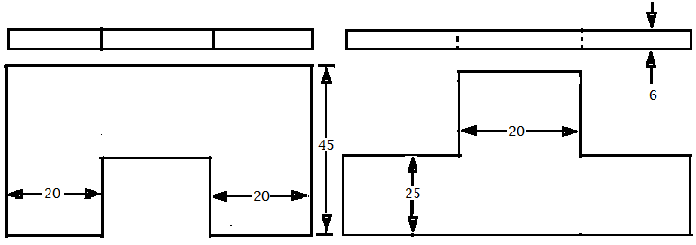

**(All dimensions are in ‘mm’)**

**Report the following**

**1.** How vice are specified? Name the different types of vices.

**2.** Name the different marking and measuring tools used in the fitting shop?

**3.** How files are classified? Describe with neat sketches.

**Date__________** **Teacher’s Signature_________**

**ASANSOL ENGINEERING COLLEGE**

MECHANICAL ENGINEERING DEPARTMENT

PRACTICE OF MANUFACTURING PROCESS (PC ME 391)2023

**JOB-(02)**

**NAME- _______________________________________UNIV. ROLL NO-­­­______________________________**

**DEPARTMENT-________________________________GROUP -_____________________________________**

**OBJECTIVE:** To prepare two piece split pattern from a light wood as per dimension by wood turning lathe.

**MATERIAL REQUIRED:** 150 × 050 Gamhar/Sal wood.

**APPARATUS:** Steel ruler, saw, rasp cut file, , claw hammer & Carpentry vice.

**MACHINE REQUIRED-**Wood turning lathe

**FIGURE:**

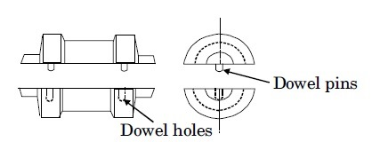

**(All dimensions are in ‘mm’)**

**Report the following**

1. Describe the method of preparation of two piece split pattern with neat sketch?

2. Write the name of the tools required for making the pattern.

3. What are the common materials used for making pattern? Write their relative merits & demerits.

4. How the layout of a pattern made? Explain (a) follow board (b) core prints.

5. What do you understand by the term gating system? Name the types of gates used in moulding?

**Date__________** **Teacher’s Signature______________**

**ASANSOL ENGINEERING COLLEGE**

MECHANICAL ENGINEERING DEPARTMENT

PRACTICE OF MANUFACTURING PROCESS (PC ME 391)2023

**JOB-(03)**

**NAME- _________________________________________ UNIV. ROLL NO-­­­_______________________**

**DEPARTMENT-__________________________________ GROUP -_______________________________**

**OBJECTIVE**: To prepare a Plumb Bob.

**MATERIAL REQUIRED:** 45 × 40 mm2 dia of M.S. round bar.

**APPARATUS**: Lathe, single point HSS tool, steel ruler, outside caliper, jenny caliper, surface gauge, chuck key, tool post wrench.

**FIGURE:**

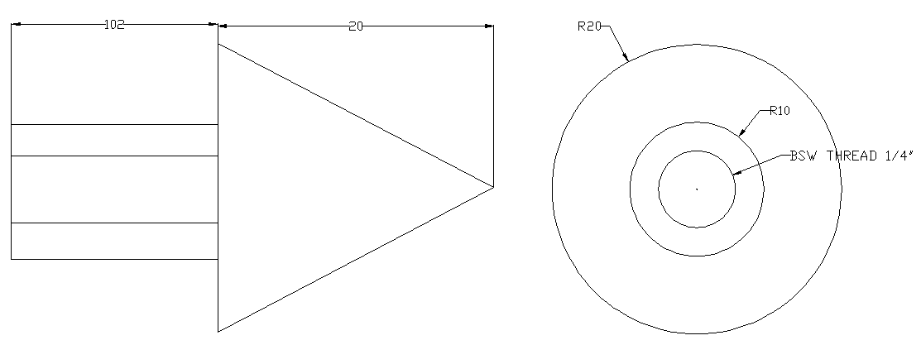

**(All dimensions are in ‘mm’)**

**Report the following**

1. What are the basic parts of an engine lathe? Discuss the function of head stock.

2. Why chucks are used? List various types of chucks used in lathe. Describe any one in brief.

3. Define taper turning and taper. Name the different methods of taper turning done on a center lathe.

4. Define feed and depth of cut. Describe tumbler gear mechanism.

**Date__________** **Teacher’s Signature_________**

**ASANSOL ENGINEERING COLLEGE**

MECHANICAL ENGINEERING DEPARTMENT

PRACTICE OF MANUFACTURING PROCESS (PC ME 391)2023

**JOB-(4)**

**NAME- _________________________________________ UNIV. ROLL NO-­­­___________________________**

**DEPARTMENT-__________________________________ GROUP -__________________________________**

**OBJECTIVE:** To fabricate a welded butt joint by MMA Welding method using MS Plate.

**MATERIAL REQUIRED:** 85 × 50× 6 mm3 MS flat Plate.

**APPARATUS:** Bench vice, Steel Ruler, Try-square, Hacksaw, Files, Scriber & Welding Setup.

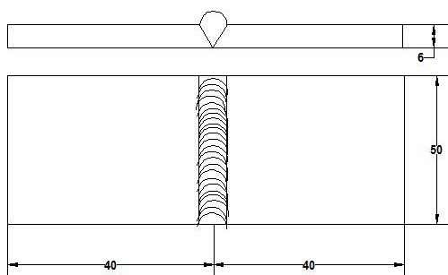**FIGURE:**

**(All dimensions are in ‘mm’)**

**Report the following**

**1.** State the various equipments/accessories required for MMA Welding and briefly describe their functional requirements with circuit diagram.

**2.** What is Edge Preparation and why it is necessary? Show various types of prepared edge with neat sketch.

**3.** Explain the different types of welding defects?

**Date__________** **Teacher’s Signature_________**

**ASANSOL ENGINEERING COLLEGE**

MECHANICAL ENGINEERING DEPARTMENT

PRACTICE OF MANUFACTURING PROCESS (PC ME 391)2023

**JOB-(05)**

**NAME- _________________________________________ UNIV. ROLL NO-­­­___________________________**

**DEPARTMENT-___________________________________ GROUP -__________________________________**

**OBJECTIVE:** To fabricate a welded joint by gas welding method using MS Square Pipe.

**MATERIAL REQUIRED:** 85 × 25 × 25 mm2 MS Square pipe

**APPARATUS:** Steel Ruler, Try-square, Hacksaw, File, scriber & Gas Welding Set up.

**FIGURE:**

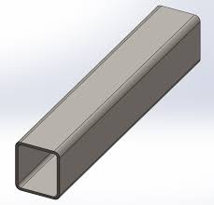

WELDED PORTION

25

25

40

40

**(All dimensions are in ‘mm’)**

**Report the following**

1. State the various equipment/accessories required for Gas Welding.

2. What is gas welding?

3. What are the different types of gas flames produced during gas welding explain with figure? What is the difference between Gas Welding & Arc Welding?

4. Explain the different types of welding defects?

**Date__________** **Teacher’s Signature________**

**ASANSOL ENGINEERING COLLEGE**

MECHANICAL ENGINEERING DEPARTMENT

PRACTICE OF MANUFACTURING PROCESS (PC ME 391)2023

**JOB-(06)**

**NAME- _________________________________________ UNIV. ROLL NO-­­­___________________________**

**DEPARTMENT-___________________________________ GROUP -__________________________________**

**OBJECTIVE**: To prepare a scriber from M .S. round bar as per dimension.

**MATERIAL REQUIRED:** ∅6 × 200mm M.S. round bar.

**APPARATUS:** Steel ruler, flat & ring tong, sledge hammer, hacksaw, hot chisel and anvil.

Operation:-Measuring, marking, cutting, upsetting and finishing

**FIGURE:**

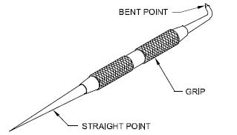

**(All dimensions are in ‘mm’)**

**Report the following**

1. Describe the method of preparation of chisel with neat sketch.

2. Name the different types of tongs used in forging process. Describe with neat sketch.

3. What are the common forging defects and why they occur?

4. Write short notes on (a) Swages (b) Fullers (c) Drifts and (d) Punch.

**Date__________** **Teacher’s Signature________**

**ASANSOL ENGINEERING COLLEGE**

MECHANICAL ENGINEERING DEPARTMENT

PRACTICE OF MANUFACTURING PROCESS-II (PC ME 391)2023

**JOB-(07)**

**NAME- __________________________________ UNIV. ROLL NO-­­­____________________________________**

**DEPARTMENT-___________________________GROUP -___________________________________________**

**OBJECTIVE:** To prepare a sheet metal product (rectangular tray).

**MATERIAL REQUIRED:** G.I. sheet.

**APPARATUS:** Snip, steel ruler, mallet, scriber, stake and straight, soldering pest edge soldering iron.

**FIGURE:**

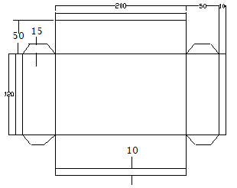

**(All dimensions are in ‘mm’)**

**Report the following**

1. Describe the method of preparation of tray with neat sketch.

2. What are the commonly used materials in sheet metal? How is sheet metal specified?

3. What are the different types of soldering? State its composition and application.

4. Name and explain various hand tools used in sheet metal work.

**Date__________** **Teacher’s Signature_______________**